Therefore prophesy, and say to them, “Thus says the LORD God: ‘Behold, I will open your graves, and raise you from your graves, O My people; and I will bring you home into the land of Israel. And you shall know that I am the LORD, when I open your graves, and raise you from your graves, O My people.’” Ezekiel 37:12-13
Click on this word. A box should appear. This box is for the particulars of the congregation, time, address, pastor, etc.
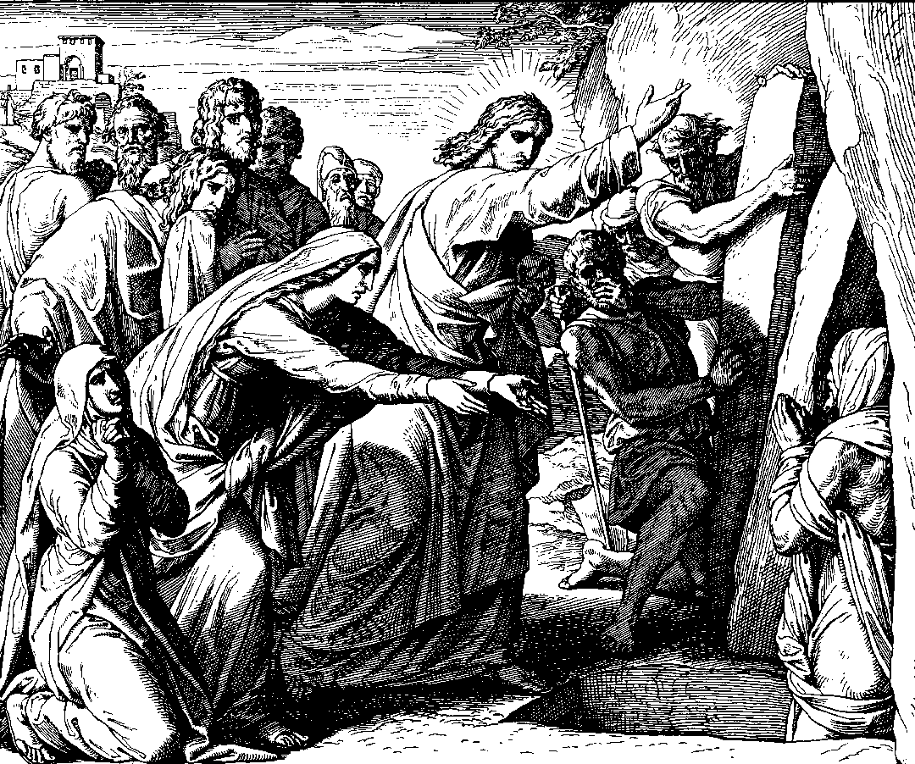
And, because on the aforesaid Feast of the Passover all sorts of folks had come up to Jerusalem, he permitted such a title be written in the three principal languages (Hebrew, Greek, and Latin) and in these words: Jesus of Nazareth, the King of the Jews. Such a superscription would have been read by many Jews and the comrades of the Jews at that time, because the place of crucifixion was next to Jerusalem. Thus, the high priests would not permit this. Instead, they petitioned Pilate to change the title to this extent: namely, that Christ merely represented Himself as and claimed to be the King of the Jews, while in fact He was not. However, Pilate answered them: What I have written, that I have written; [that is,] I will leave stand what I have already written.
From this we must first of all learn, as the evangelist John states, chapter 11, that the high priest Caiaphas had unwittingly prophesied about the result of Christ’s death when he said: It is better for us that One Man die for the people than that the entire nation perish.

An Explanation of the History of the Suffering and Death of our Lord Jesus Christ
by Johann Gerhard
pages 246-247
© 1998 by Elmer Hohle, Published by Repristination Press in 1999.
Used with permission.
The Fifth Sunday in Lent

17 March Anno Domini 2002

It is expedient for you that one man should die for the people. (John 11:50)
Jesus Raises Lazarus by Julius Schnoor von Carolsfeld.
Permission to use this image is limited to personal and congregational use.
Courtesy of Wisconsin Evangelical Lutheran Synod - the World Mission Collection.

Scripture text is based on Revised Standard Version © 1946, 1952, 1971 Division of Education and Ministry of the National Council of the Churches of Christ in the United States of America.
All Rights Reserved.

This bulletin cover made available by www.scholia.net and is provided without cost.

Therefore prophesy, and say to them, “Thus says the LORD God: ‘Behold, I will open your graves, and raise you from your graves, O My people; and I will bring you home into the land of Israel. And you shall know that I am the LORD, when I open your graves, and raise you from your graves, O My people.’”

Ezekiel 37:12-13
And, because on the aforesaid Feast of the Passover all sorts of folks had come up to Jerusalem, he permitted such a title be written in the three principal languages (Hebrew, Greek, and Latin) and in these words: Jesus of Nazareth, the King of the Jews. Such a superscription would have been read by many Jews and the comrades of the Jews at that time, because the place of crucifixion was next to Jerusalem. Thus, the high priests would not permit this. Instead, they petitioned Pilate to change the title to this extent: namely, that Christ merely represented Himself as and claimed to be the King of the Jews, while in fact He was not. However, Pilate answered them: What I have written, that I have written; [that is,] I will leave stand what I have already written.
From this we must first of all learn, as the evangelist John states, chapter 11, that the high priest Caiaphas had unwittingly prophesied about the result of Christ’s death when he said: It is better for us that One Man die for the people than that the entire nation perish.

An Explanation of the History of the Suffering and Death of our Lord Jesus Christ
by Johann Gerhard
pages 246-247
© 1998 by Elmer Hohle, Published by Repristination Press in 1999.
Used with permission.
To place the graphic on this page:
Click on the graphic on the previous page and copy it.
Come down to this page. Click on the open space above and a graphic box should appear. Paste the graphic.

Change this frame and the box above by clicking the body of the text, deleting this text (not the box) and adding your particulars.
The Fifth Sunday in Lent

17 March Anno Domini 2002
Jesus Raises Lazarus by Julius Schnoor von Carolsfeld.
Permission to use this image is limited to personal and congregational use.
Courtesy of Wisconsin Evangelical Lutheran Synod - the World Mission Collection.

Scripture text is based on Revised Standard Version © 1946, 1952, 1971 Division of Education and Ministry of the National Council of the Churches of Christ in the United States of America.
All Rights Reserved.

This bulletin cover made available by www.scholia.net and is provided without cost.

It is expedient for you that one man should die for the people.

John 11:50

